Create Subreport
Step 1: Create 2 reports
Step 2: In the query window write the below query for the 2nd report that will be the Subreport
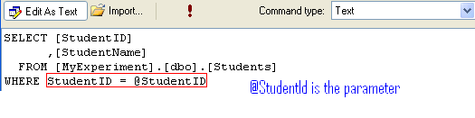
Step 3: Create the report as outlined in Document 1
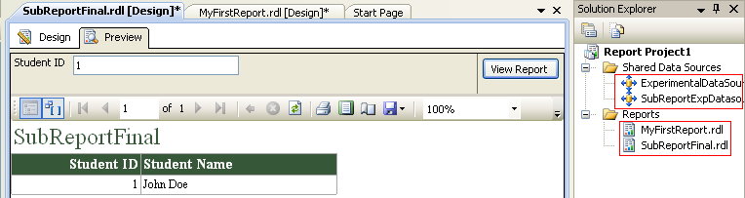

Step 4: Add a SubReport control in the main report
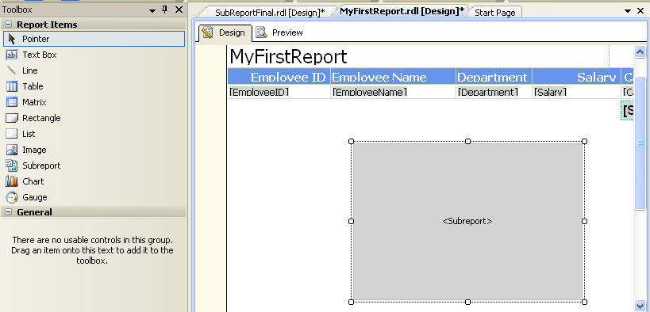
Step 5: Right Click on the Subreport -> Subreport Properties
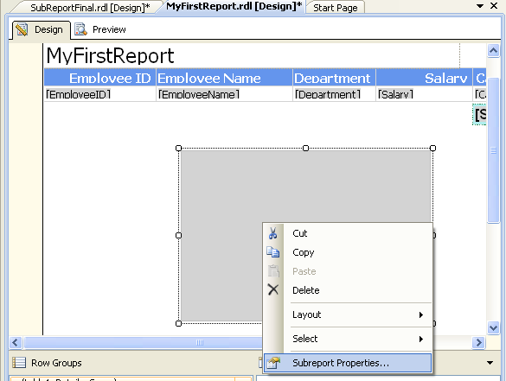

Step 6:
Do the changes in the General Section
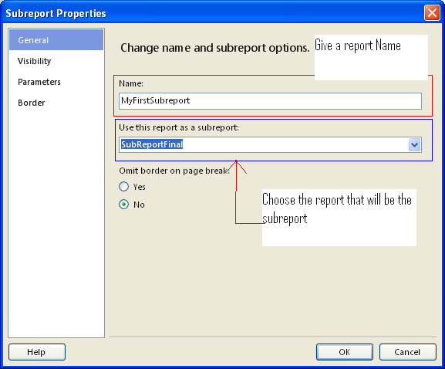

Step 7: Do the changes in the Parameter Section. Click on Add button first then choose the Name and Value. Click OK
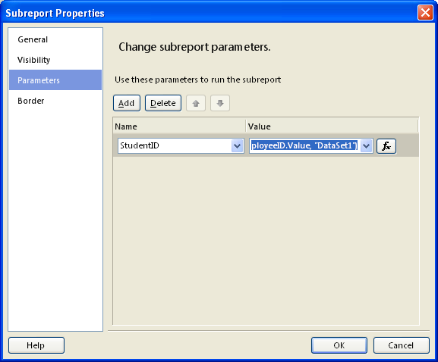
Step 8:
